**Agriculture and Technology – RIQ-321**

**Name: _____________________________________________**

List **x3** facts you **recall** about the content covered in today’s lesson:

1. __________________________________________________________________________________________________________________________________________________________________
2. __________________________________________________________________________________________________________________________________________________________________
3. __________________________________________________________________________________________________________________________________________________________________

List **x2 interesting** observations you found from today’s lesson:

1. __________________________________________________________________________________________________________________________________________________________________
2. __________________________________________________________________________________________________________________________________________________________________

Write **x1 question** you have about the content covered from today’s lesson:

1. __________________________________________________________________________________________________________________________________________________________________

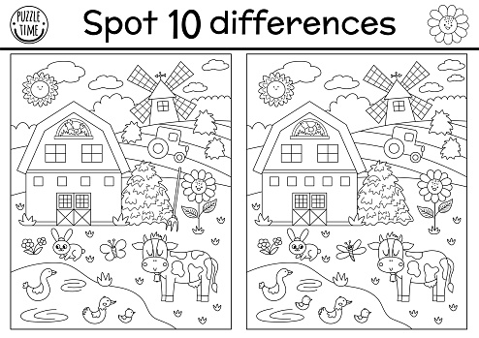

**Spot the 10 differences**